Instruction Manual 使用说明书

Specification
规格
Product Name:Mining Light Bar
产品名称 ：矿灯
Working Voltage:12-24VDC
工作电压：12-24V直流
Parts of the Light Bar: Strobe light(optional)
警示灯各部分：频闪灯（可选）
Backup alarm
倒车警报
Tail lihgt kits
尾灯套件
Work light(optional)
工作灯（可选）

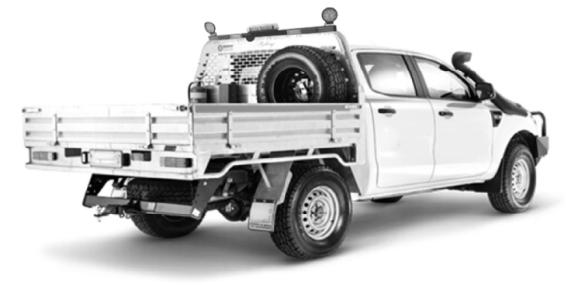

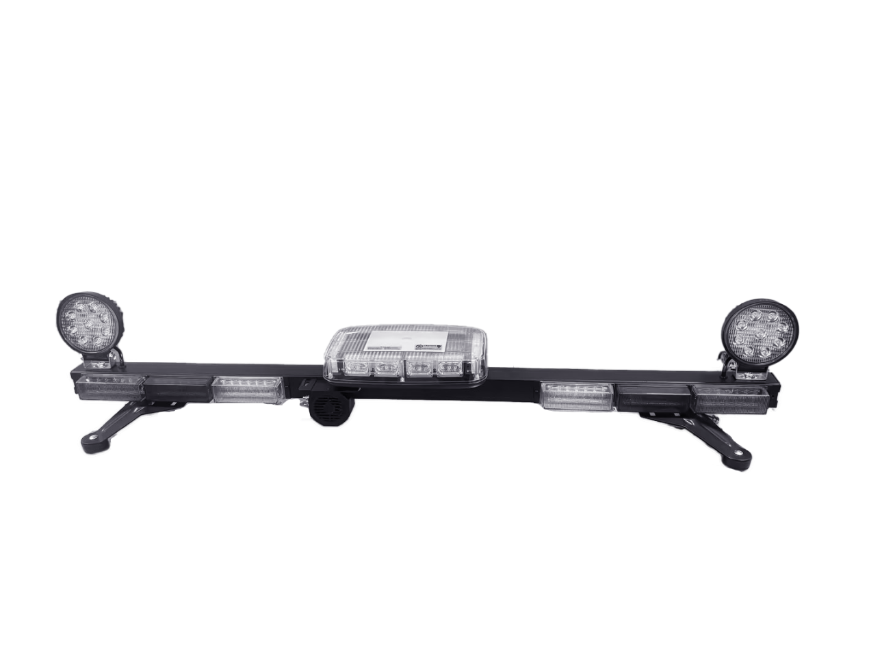

Work light Strobe light Work light
工作灯 频闪灯 工作灯

Left turning light Brake&driving light Reverse light Backup alarm Reverse light Brake &driving light Right turning light
左转向灯 刹车灯与行车灯 倒车灯 倒车报警 倒车灯 刹车灯与行车灯 右转向灯

- Black wire connects to Negative(-)Pole of Power.
黑色线连接到电源负极(-)。
- Red wire connects to Brake Light(+)
红色线连接到刹车灯( +)
3.White wire connects to Reverse Light(+)(while reversing,the backup alarm will whistle).
白色线连接到倒车灯( )(倒车时，倒车警报器将鸣响)。
4.Yellow wire connects to Left-turning light(+).
黄色线连接到左转向灯(+ )。
5.Yellow wire connects to Right-turning light(+).
黄色线连接到右转向灯( +)。
- Grey wire connects to Driving light(+).
灰色线连接到行车灯( +)。
- Brown wire connects to the Strobe light(+) Work light:red wire(+)black wire (-)
棕色线连接到频闪灯(+ )，工作灯：红色线(+ )，黑色线(-)

Instruction Manual 使用说明
Part No.: | Ref Image | Spacifcation | Qty | Part No.: | Ref Image | Specification | Qty
序号 | 参考图片 | 说明 | 数量 | 序号 | 参考图片 | 说明 | 数量
A | 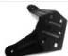 |  | 2 | A |  | Dia.12mm | 4
B | 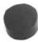 |  | 4 | B |  |  | 2  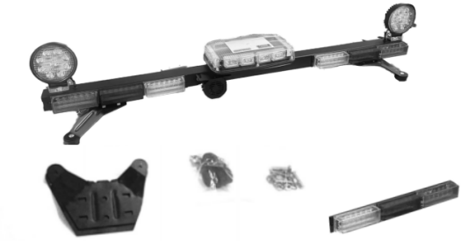
C | 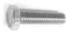 | M8*50 | 4 | C | 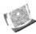 |  | 2
D | 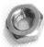 | M8 | 4 | D |  | M6*65mm | 2
E | 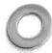 | Dia.24mm | 4 | E | 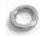 | Dia.15mm | 2
F | 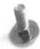 | 1/4*24mm | 4 | F | 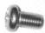 | 1/4*15mm | 2
G | 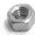 | 1/4 | 6 | G | 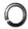 | Dia.10mm | 2
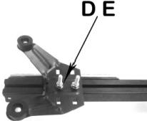
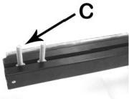
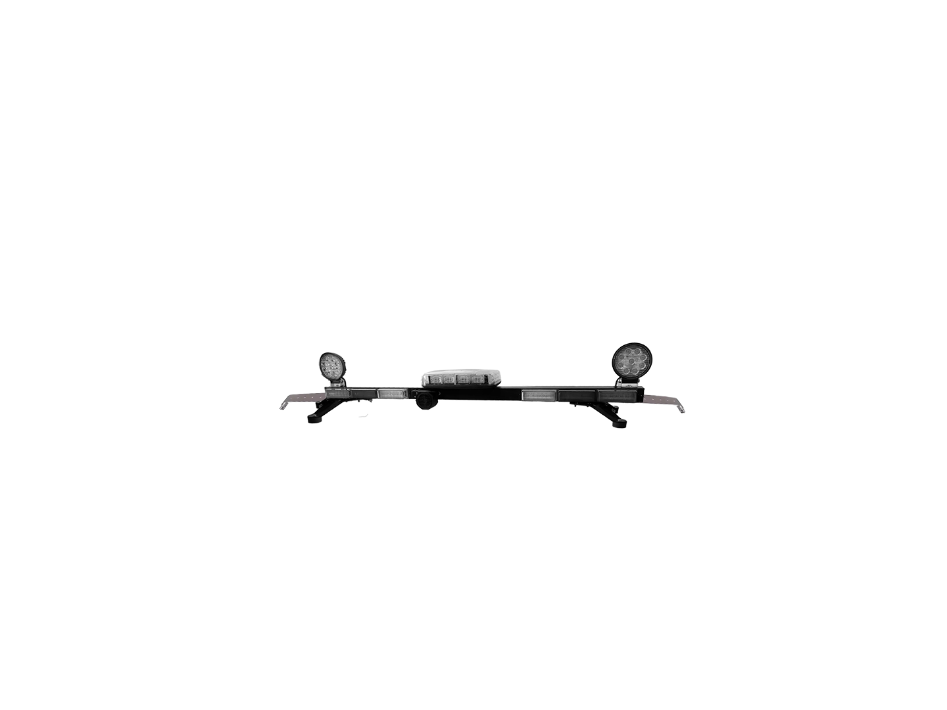
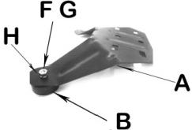
1.A ssemble Rubber Cap B on the Bracket A with Screw 2.Put two Screws C on the bottom of the light bar 3.Assemble Bracket A on the light bar with Screw C Dand Washer E
FGwith Washer H将橡胶帽安装在支架A上 在灯条底部安装两颗螺丝 使用螺丝CD和垫圈E将支架A安装在灯条上，使用螺丝FG和垫圈H

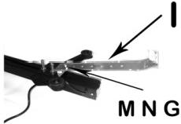

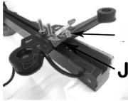
KL

4.Assemble ConnectorJ to B racket with Screw K and Washer L 5.Assemble Hook I to Connector with Screw M Nand 6. Install the whole light bar to car roof top by the hook I
使用螺丝K和垫圈L将连接件J组装到支架上 Washer G使用螺丝M和垫圈G将钩I组装到连接件上 通过钩 I将整个灯条安装到车顶

