1.Product title
LED warning lightbar for police car or firefighter truck, 1122mm length,red color,high brightness,best quality
2.Product picture(see picture)
3.Product detail information
Product Name | Lightbars
Product Model | XB12/24-B3A50
Color | Red
Rated Voltage | DC12V/DC24V
Working Voltage | DC12V：10V ～ 16V/DC24V：20V ～ 30V
length | 1122MM
Installation | U Shape bracket
Speaker Power | 50W
Flickering Direction | Front
Flickering Mode | 8-15 modes
Lamp Flux | Above 230cd
Waterproof | JIS C 0920 IP44
Cable | 0.5sq×9 line cords
Dimension | 1122mm*300mm*152mm
Net weight | About 16.1kg

4.Product business items
MOQ | 1 Set
Price | Negotiation,depend on the quantity of order.
Payment Terms | T/T
Produce Capability | 500 set per month
Delivery Time | Depend on the quantity of the order.
Packing | Carton for per product and wooden case for outside packing.

5. Product introduction

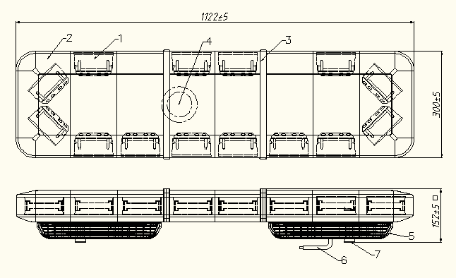
No. | Name | No. | Name
① | ＬＥＤ Unit | ⑤ | Speaker unit
② | Lamp Dome | ⑥ | Cable
③ | Center plate | ⑦ | U Shape Bracket
④ | Speaker

2．Competitive advantage:
1)Advantages: High power LED as light source, long service life, low consumption, high brightness, meet warning equipment standard.
2)Special design:advantage technique for lighting design,light can be seen in any direction;
3)Ultra-thin design,sound part is 152mm and it below the light body, the height of lightbar is 90mm totally.
4)Special technique for button part, that make current more stabilized and long working life for LED parts. Flicking part is control by separately way in order to make stable light.
5)Lamp dome was used the new technique for produce, it will no fade in the using
life.
6)Lamp flux can meet with the ECE R65 standard.
7)Appearance design patent.

3.Application:
It can be used in the special car, like policeman car, fire truck, ambulance,
engineering vehicle and on so.
- Relate product: Controller
Normal products have 8 type of flicking mode, but our controller can improve 12 type of flicking mode and more convenience to control the light.
This controller is not one part of this lightbar, please consult us if you want to buy.
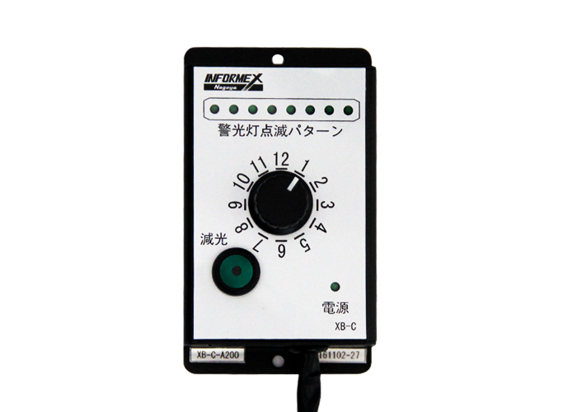
5.OEM service:
We are the professional warning lightbar producer. R&D is our advantage and we can do any size\length\color lightbars, we can provide product design\ mold design\ injection\ assembly\packing\after-sale service for every customers.
So please no hesitate to insult us for any questions.

